  - Module-1) Se - Overview Of It Industry
1.What a Program is and how it functions.

A Program is set instructions for a computer to execute specific tasks. It contains code written in a programming language which may be interpreted, compiled or assembled into machine readable form and then executed.
2.what are the key steps involved in the programming process

Here's a breakdown of the key stages: SDLC ( Software Development Life Cycle)

- Planning /Analysis:
Clearly understand the requirements, objectives, inputs, and expected outputs of the program.
- Design:
Develop a logical plan, often using algorithms (step-by-step instructions in plain English) and flowcharts (diagrams) to map the solution.
- Coding/Development:
Translate the design into actual code using a specific programming language (e.g., Python, Java, C++).
- Testing/Debugging:
Run the program with various test cases (including edge cases) to find and fix errors (bugs).
- Implementation/Deployment:
Deploy the finished software for users.
- Maintenance/Documentation:
Provide ongoing support, updates, and create documentation (like flowcharts, pseudocode, user guides) for future reference.
3. What are the main differences between high-level and low-level programming languages?

Feature | High-Level Languages | Low-Level Languages
Abstraction | High (closer to human language) | Low (closer to machine code)
Readability | Easier to read, write, and understand | Difficult; requires knowledge of machine architecture [2]
Execution | Slower; requires a compiler or interpreter | Faster; directly executed by the CPU [2, 3]
Memory Management | Often automatic (garbage collection) | Manual; programmer manages memory directly [4]
Control | Less direct control over hardware | Direct control over CPU, memory, and registers [3]
Examples | Python, Java, C++, JavaScript [2] | Assembly, Machine Code [3]
Portability | Highly portable across different systems | Not portable; specific to a CPU architecture [4]

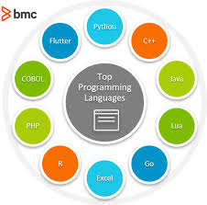
Procedural language
- C language

Object oriented programming language

- C++ language

Logical programming
- prolog programming

Functional Programming
- Phython programming

World Wide Web & How Internet Works

1 Describe the roles of the client and server in web communication.

In a client-server network, the client is responsible for initiating requests and interacting with the user. It sends requests to the server, which processes these requests and returns the requested information or performs the necessary tasks.

2 Explain the function of the TCP/IP model and its layers.
The TCP/IP model is the foundational four-layer conceptual framework (layers: Application, Transport, Internet, Network Access) used for transmitting data across the internet by breaking messages into packets, addressing, routing, and reassembling them securely

3 Types of Internet Connections

There Is 4 Type of Networks
- PAN (Personal Area Network):
Connects devices within an individual's immediate workspace, like a Bluetooth mouse to a laptop or a smartwatch to a phone.
- LAN (Local Area Network):
Links computers and devices in a limited area, such as a home, office, or school, allowing for high-speed resource sharing.
- MAN (Metropolitan Area Network):
Spans a city or large campus, connecting multiple LANs for city-wide communication, often used by large organizations or ISPs.
- WAN (Wide Area Network):
Covers vast distances, connecting networks across regions, countries, or continents; the Internet is the most prominent example, using technologies like leased lines and satellites.

4 What Are Protocols?

There Is Total 4 Types of Network Protocols

- Http And Https : Hypertext Transfer Protocol and Hypertext Transfer Protocol Secure
- FTP : File Transfer Protocol
- Email : POP3 (Post Office Protocol) And SMTP (Simple Mail Transfer Protocol)
- TCP & UDP : Transmission Control Protocol and User Datagram Protocol

5 What Is Application Security?

Application security (AppSec) is
the practice of protecting software applications from threats, vulnerabilities, and unauthorized access throughout their entire lifecycle—from design and development to deployment and maintenance. It involves implementing security measures, such as code analysis, firewalls, and, importantly, the principle of least privilege, to prevent data theft or manipulation.

6 What Is Application Software?

An application is software that bundles together certain features in a way that is accessible to a user. There are millions of apps on both the App Store and Android app stores, offering services (or verticals).

7 Software Applications and Its Types

There Is Total 5 Types Of Software Application And Its Mentioned Below,

- Applications Software : Ms Office, Paint, PowerPoint
- System Software : Notepad, Calculator, OS Is Most Commonly Example OS System Software
- Driver Software : Audio Driver, Video Driver
- Middleware : Data base, Software that acts as a "bridge" or "plumbing" between different applications, tools, and databases to enable seamless data exchange, communication, and management
- Programming Software : Turbo, Eclipse, Sublime, Visual Studio Code, IntelliJ IDEA, Xcode, and Android Studio
8 Software Architecture

Modularity in software architecture is the practice of dividing a system into distinct, independent, and interchangeable components or "modules" that encapsulate specific functionality. Its significance lies in enhancing maintainability, reusability, and scalability, allowing for parallel development, easier debugging, and reduced risk during system updates.

9 Layers in Software Architecture

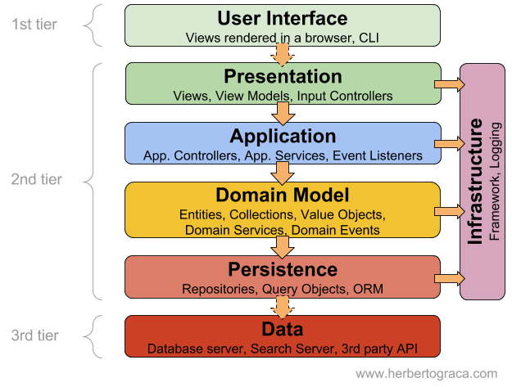
Total 5 Type Of Layers In Software Applications

- Presentation Layer : commonly referred to as the User Interface (UI) Layer, is the topmost layer in a multi-tier software architecture. It serves as the direct interface between the end-user and the application, responsible for displaying information and capturing user inputs.
Key functions and details of the Presentation Layer include:
- Data Formatting & Translation: Converts data between different character encodings (e.g., EBCDIC to ASCII) and structures to ensure compatibility between diverse systems.
- Data Compression: Reduces the size of data to optimize bandwidth and improve transmission speed, using methods like JPEG for images or MPEG for video.
- Encryption & Decryption: Provides security by encrypting data at the source and decrypting it at the destination, essential for secure communication protocols.
- Syntax Management: Handles how data is structured (syntax) to ensure the receiving application understands the message.
- Examples & Protocols: While not typically a standalone protocol layer in the TCP/IP stack (often merged with the application layer), it handles standards such as SSL/TLS for encryption and media formats like JPG, GIF, and MIDI.

- Application Layer : Examples of protocols operating at the Application Layer include Hypertext Transfer Protocol (HTTP) for web browsing, File Transfer Protocol (FTP) for file transfers, Simple Mail Transfer Protocol (SMTP) for email services, and Domain Name System (DNS) for resolving domain names to IP addresses.
Key functions and characteristics include:

- Direct User Interaction: The layer closest to the end-user, facilitating applications to interact with the network.
- Protocol Support: Utilizes various protocols for specific tasks, including HTTP (web browsing), FTP (file transfer), SMTP (email), and DNS (domain name resolution).
- Data Formatting:
Handles data compression, encryption, and ensures data is in a readable format
.
- Network Access: Identifies communication partners, determines resource availability, and synchronizes communication.
- Model Integration: In the OSI model, it is the 7th layer, while in the TCP/IP model, it combines the functionalities of the top three OSI layers (Application, Presentation, Session).

- Business Layer : Also Called Domain Layer the core component of software architecture that houses business logic, rules, and workflows. Positioned between the user interface (presentation layer) and the database (data access layer), it dictates how data is processed, validated, and managed. This layer enhances modularity.
Key Aspects of the Business Layer
- Definition & Role: Often called the "domain layer," it acts as the brain of the application, determining how data is used, what it can perform, and its limitations based on organizational guidelines.
- Key Responsibilities:
  - Implementing Business Rules: Enforcing logic such as calculating taxes, processing orders, or checking user eligibility.
  - Data Manipulation: Transforming data from the database into a format suitable for the user interface.
  - Validation: Ensuring input data meets requirements before proceeding.
  - Workflow Coordination: Managing the sequence of actions, such as ordering steps in an e-commerce checkout.

- Persistence Layer : A persistence layer is a software abstraction acting as a bridge between an application's business logic and its underlying database, handling data storage, retrieval, and updates. It encapsulates data access logic (e.g., SQL queries, API calls) using CRUD operations, allowing developers to separate domain logic from storage mechanisms.
Key Aspects of a Persistence Layer:

- Abstraction & Separation: It isolates the business layer from the database technology, making it easier to change databases without affecting the application.
- Data Mapping: It maps object-oriented code to relational database tables, often using Object-Relational Mapping (ORM) frameworks like Hibernate or Entity Framework.
- Key Components: Typically includes Data Access Objects (DAOs), repositories, and data transfer objects (DTOs) to manage data flow.
- Benefits: Improves data integrity, scalability, and maintainability by centralizing data access logic.
- Transaction Management: It manages data consistency by handling database transactions, ensuring that data is correctly stored, updated, or deleted.
Database Layer : A database layer, or Data Access Layer (DAL), is the component in software architecture responsible for managing data storage and retrieval, acting as a bridge between the business logic and the actual data (like SQL, MongoDB). It provides a consistent API to hide database specifics, allowing applications to interact with data using common functions (CRUD: Create, Read, Update, Delete) without needing to know complex database details or vendor specifics, improving portability and maintainability.
Key Functions & Characteristics
- Data Persistence: Stores and retrieves application data, including tables, indexes, and files.
- Abstraction: Hides the complexity of the underlying database (e.g., MySQL, Oracle, NoSQL) from the business logic layer.
- Consistency: Offers a unified way to perform data operations (SQL queries, API calls).
- Security: Manages data access, authorization, and sometimes encryption.
- Modularity: Separates data handling from business rules, making the application easier to maintain and change.

10 Software Environments :

- The Analysis And Design Environment
- The Development Environment
- The Common Build Environment
- The Testing Environment
- The Production Environment

11 Source code :
Source code is the set of instructions that a programmer writes to create software. Every instruction (also known as an algorithm) is written in a specific programming language, such as Python, HTML, C++, or Java. Source code is like a detailed recipe for computers to follow
12 What are the differences between open-source and proprietary software.
- Source Code Access & Modification: Open-source (OSS) allows users to inspect, modify, and enhance code, promoting customization and innovation. Proprietary (closed-source) software prohibits users from accessing or changing the code, limiting modifications to the vendor.
- Cost: OSS is often free to use, though costs may arise from implementation or support. Proprietary software requires purchasing licenses or subscriptions, which can lead to higher long-term costs.
- Support & Maintenance: OSS relies on community forums, documentation, and user, while proprietary software provides dedicated, guaranteed support from the vendor.
- Security & Updates: OSS allows for rapid, transparent, community-driven patching of security vulnerabilities. Proprietary software relies on the vendor to release updates, which can be slower.
- Flexibility & Customization: OSS offers high flexibility for tailoring the software to specific needs. Proprietary software is less flexible, designed for, and limited to, the features provided by the creator.
Examples
- Open-Source: Linux, Android, Mozilla Firefox, WordPress.
- Proprietary: Windows, macOS, Microsoft Office, Adobe Creative Cloud.
13 How does GIT improve collaboration in a software development team?

Git makes collaborative development easy through its branching model where team members can create branches, experiment, and merge code to the main branch if successful. Git tracks changes during code reviews and enables collaboration through merge requests or pull requests.

14. What is the role of application software in businesses?
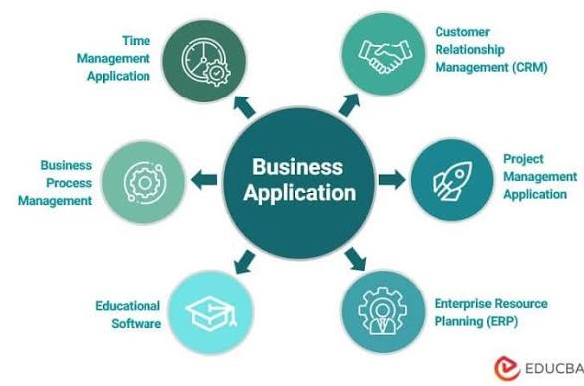
Application software acts as a specialized,, purpose-built tool designed to automate, manage, and optimize core business operations, significantly enhancing efficiency, productivity, and decision-making. By streamlining processes like accounting, CRM, and inventory management, it reduces manual errors, enables remote collaboration, and scales with company growth.

15. What are the main stages of the software development process?
The requirement analysis phase is critical in software development because
it defines the project scope, aligns stakeholder expectations, and prevents costly, time-consuming reworks later. By establishing a detailed Software Requirement Specification (SRS) document early, teams can mitigate risks, identify potential issues, and ensure the final product meets user needs and business objectives.
16. What are the key elements of system design?
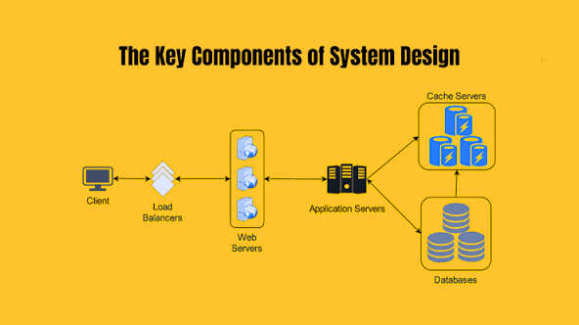
Key elements of system design include defining the architecture, components, modules, interfaces, and data for a system to satisfy specific requirements. Core components consist of load balancers, database sharding, caching, messaging queues, and microservices. Key principles focus on scalability, reliability, availability, and performance.
17. What types of software maintenance are there?
1. Corrective Maintenance
- Purpose: To fix defects, errors, or bugs found in the software.
- Example: Releasing a patch to resolve a crash that occurs when a user clicks a specific button.
2. Adaptive Maintenance
- Purpose:
To modify the software to remain compatible with changes in its external environment, such as new hardware, operating systems, or regulations.
- Example:
Updating an application to work with the latest version of Windows or a new database system.
3. Perfective Maintenance
- Purpose:
To improve the software's functionality, performance, usability, or maintainability, often based on user feedback or changing requirements.
- Example:
Adding a new feature, optimizing a slow report, or restructuring code for better readability.
4. Preventive Maintenance
- Purpose:
To proactively identify and fix potential problems and improve the software's robustness to prevent future issues.
- Example:
Optimizing code, updating documentation, refactoring complex modules, or implementing better backup strategies.

18. What are the differences between native and hybrid mobile apps?
Native apps are built specifically for one platform (iOS or Android) using platform-specific languages, offering superior performance and full hardware access, but higher costs
. Hybrid apps combine web technologies (HTML, CSS, JavaScript) inside a native wrapper to run on multiple platforms from a single codebase, offering faster development at a lower cost, though with slightly lower performance.

19. What is the significance of DFDs in system analysis
Data Flow Diagrams (DFDs) are essential in system analysis for modeling how data moves, is processed, and is stored within a system. They provide a clear visual representation, making complex systems understandable for both technical and non-technical stakeholders, improving communication, identifying bottlenecks, and aiding in system design and documentation.

20. What are the pros and cons of desktop applications compared to
web applications?
Pros of Desktop Applications
- Performance & Speed: They run directly on local hardware, offering faster performance for data-intensive operations (e.g., video editing, 3D rendering).
- Offline Functionality: They do not require an active internet connection to operate.
- System Integration: Better access to system resources like local file systems, notifications, and specialized hardware.
- Security: Data can remain stored locally, offering better control over data privacy.
Cons of Desktop Applications
- Installation & Maintenance: They must be installed on each device, and updates are typically manual or require user interaction.
- Platform Dependency: They often need separate versions developed for different operating systems (Windows, macOS, Linux).
- Lower Accessibility: Limited to the specific machine on which they are installed.
- Higher Development Costs: Generally higher upfront development and QA costs due to device variations.
Pros of Web Applications (for comparison)
- Instant Accessibility: Accessed via browsers from any device with an internet connection.
- Easy Maintenance: Updates are deployed centrally, so all users always have the latest version.
- Scalability: Easier to manage user growth through cloud infrastructure.
Cons of Web Applications (for comparison)
- Internet Dependency: Generally require a stable internet connection.
- Performance Bottlenecks: Subject to browser limitations and latency.
- Security Risks: Larger attack surface due to web accessibility.
The choice between them hinges on whether the user prioritizes performance and offline access (Desktop) or flexibility and accessibility (Web).
21. How do flowcharts help in programming and system design?
Flowcharts serve as critical visual blueprints in programming and system design,
mapping out complex logic, workflows, and algorithms before code is written. They enhance understanding, improve efficiency by identifying bottlenecks, and facilitate debugging by providing a clear, step-by-step visual representation of the process flow.

22. Use case -Payment Gateway Use Case Diagram
